Terahertz Spectroscopy Measurements on Black Silicon
by
Jesper Graungaard Bertelsen
AU-ID: au689481, Study-ID: 202204617

Bachelor’s Thesis
in
Electrical Engineering

Supervisor:
Pernille Klarskov

Co-Supervisor:
Rasmus Davidsen

Aarhus University, Department of Electrical and Computer Engineering
<date of submission, e.g. 5 December 2025>

Indholdsfortegnelse
Abstract 3
Introduction 3
Eksperimental setup 3
Verifying the setup 4
Methods and theory 5
Black sillicium 5
Terahertz Time-domain Spectroscopy ( THz-TDS ) 5
Usikkerhedsberegninger 6
Experimental results 7
Discussion 8
Future work 8
Conclusions 8
References 8
Bibliografi 8

Opstilling taget fra eksempel:
- Abstract
- Introduction
- Literature Review
- Methodology
- Analysis and Discussion
- Future Work
- Conclusions
- References

Abstract

Introduction

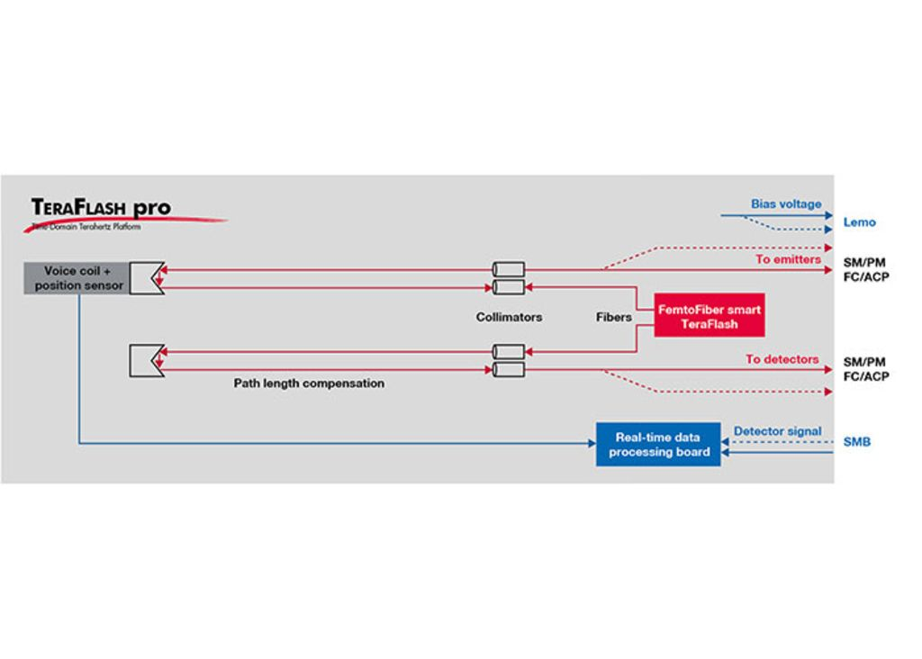
Eksperimental setup
Grej til rådighed, TeraFlash Proen af toptica.
Bord hvor man kan skrue ting fast på. Apperaturer til at holde spejle på plads og ellers justere højden for mediummet.
Grejet fra toptica bruger en FemtoFiber Smart TeraFlash laser,
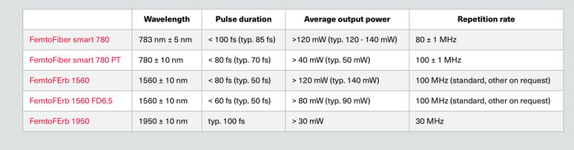
https://www.toptica.com/products/ps-fs-fiber-lasers/femtofiber-smart
På deres hjemmeside har de to kandidater som hedder noget lignende. Time steppet efter sampling afslører, at det er en 0,05ps = 50fs pulse. Dermed er det enten
FemtoFErb 1560 eller FemtoFErb 1560 FD6,5.

Verifying the setup
When having set it all up, we then want to verify, that all is working accordingly. This ensures, that the values I’ll later get can be interpreted correct. For what I’ll be using THz TDS for, it’s to describe etching of the black sillicon reference material. The refractive index of Si is well known and with the depth being known aswell, we should see the refractive index convergerging towards the refractive constant.
Using a change in refractive index of two mediums and taking that in terms of how it affects the change in phase, one can derive an expression for a uniform material to be:
$$n_{si}=\left|∆ϕ\right|·\frac{c}{ω·d}+n_{0} ⋆1$$
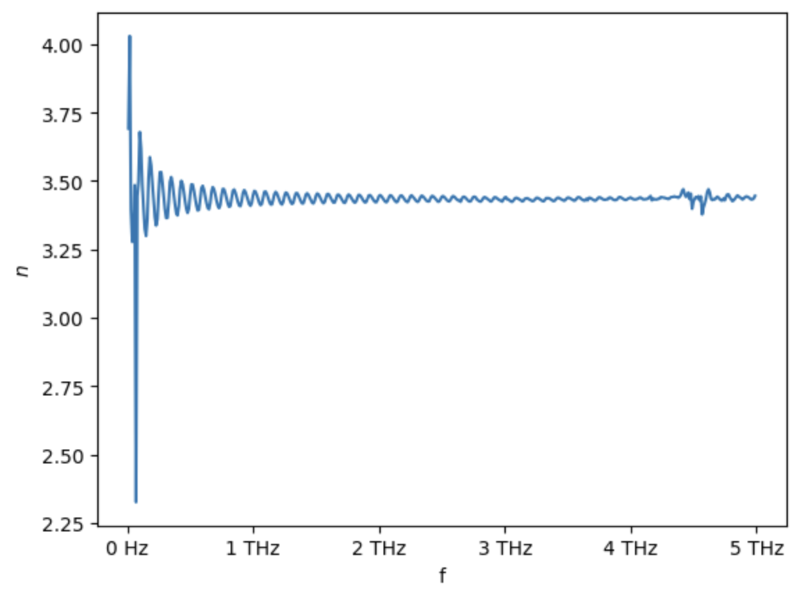
Which we can use for analysis in the frequency domain. [1]
Figure 1: The refractive index of Si varying over frequencies

Due to singularities for $\lim_{ω→0}{n_{si}\left(ω\right)}$ there is methods for overcoming that, making a new refractive index using what’s known as Phase Extrapolation
$$n_{si}^{'}\left(ω\right)=n_{si}\left(ω\right)+m·2π\frac{c}{ωd} ⋆2$$
For m being an arbitrary integer, that ensures, that the best results is seen around $ω=0$. [2]
For my reference sample, $m=0$ made for the best result, meaning that phase extrapolation didn’t help.
Then drawing conclusions from the figure, I saw my refractive index converging towards an approximate of $n_{si}≈3,43$, which are a value of the refractive index one could expect. Having gotten that verification made me able to move on towards new steps.

Methods and theory

Black sillicium
Med dens lave reflektivitet, så er black sillicium et godt materiale når det kommer til at inkapsle solens stråler, som er essencen i en solcelle…
Jeg ved ikke meget om det, men vil give det lidt tid, og prøve at få lidt teori om det indover også.

Terahertz Time-domain Spectroscopy ( THz-TDS )
Sampling I THz TDS
Forstyrrelse af medium.
Hvorfor vi bruger [0,8; 1,15] THz på grund af at $λ_{0}≫d_{film}$, som gør det muligt at approksimere til en tyndfilmsformel. $(d_{film}≪λ_{\text{eff}})$, (
Yasiths side 12.
40. Beermann, N. S.; Gebauer, A.; Fabretti, S.; Zhang, W.; Hiraoka, T.; Achtstein, A. W.; Hafez, H. A.; Turchinovich, D. Terahertz time-domain spectroscopy for simultaneous measurement of optical constants, and material thickness with deep-subwavelength precision. Optics Express 2025, 33 (6), 8650–8660. DOI: 10.1364/OE.544182
)
0,8THz er valgt af Yasith pga, stabilitet. $λ_{min}=260,9μm=>f_{max}=1,15THz$ og $d_{film}≪λ_{min}$, så jeg kunne egentlig have valgt en vilkårlig bølgelængde højere end det. Men som sagt, 0,8THz er taget pga. stabilitet.

Usikkerhedsberegninger
Da det kan være meget svært at udlede et udtryk, hvor man simpelt kan sige, at går dette udtryk mod A, så vil mit udtryk gå mod min/max, så gik jeg videre til at bruteforce beregninger.
Operationerne
Til operationerne varierer jeg først på (dref, dsam, dfilm) til indekserne (j, k, i). Dernæst varierer jeg for alle de scans som jeg gjorde til hvert type, M = 5, med indeks m.
$avg\left\{n_{f, j, k, i}\right\}$ <- Spektret fra [0,8THz; 1,15THz]. Avg. medføre en skalar
$n_{f max}=\max_{m}{\max_{j}{\max_{k}{\max_{i}{avg\left\{n_{f, j, k, i, m}\right\}}}}}$ <- Upper bound.
$n_{f mean}=\underset{m}{avg}{\underset{j}{avg}{\underset{k}{avg}{\underset{i}{avg}{avg\left\{n_{f, j, k, i, m}\right\}}}}}$ <- Mean value.
$n_{f min}=\min_{m}{\min_{j}{\min_{k}{\min_{i}{avg\left\{n_{f, j, k, i, m}\right\}}}}}$ <- Lower bound.
Og det samme for volume fraction
${volFrac}_{ max}=\max_{m}{\max_{j}{\max_{k}{\max_{i}{avg\left\{{volFrac}_{j, k, i, m}\right\}}}}}$ <- Upper bound.
${volFrac}_{mean}=\underset{m}{avg}{\underset{j}{avg}{\underset{k}{avg}{\underset{i}{avg}{avg\left\{{volFrac}_{j, k, i, m}\right\}}}}}$ <- Mean value.
${volFrac}_{min}=\min_{m}{\min_{j}{\min_{k}{\min_{i}{avg\left\{{volFrac}_{j, k, i, m}\right\}}}}}$ <- Lower bound

Experimental results
Instead of the uniformly distributed Si wafers, these types were now the result of etching the reference substances, for them to have a layer of both air and Si.

I then need an expression, that tries to find the effective refractive index given the depth of the reference, the sample and the depth of the thin film layer.
Lines formel 5.6…

Efterfinde Yasiths resultater for typerne. Kan jeg få alle de samme resultater?
Da det var så svært at efterfinde de resultater som Yasith fik, hvor meget har usikkerhederne så påvirket det?
Usikkerheder antaget anden viden ikke haves: $d_{film}±0,5μm$, $d_{ref}, d_{sam}±20μm$ ( som anvist på deres pakker, tror jeg, at det var ).
Metode
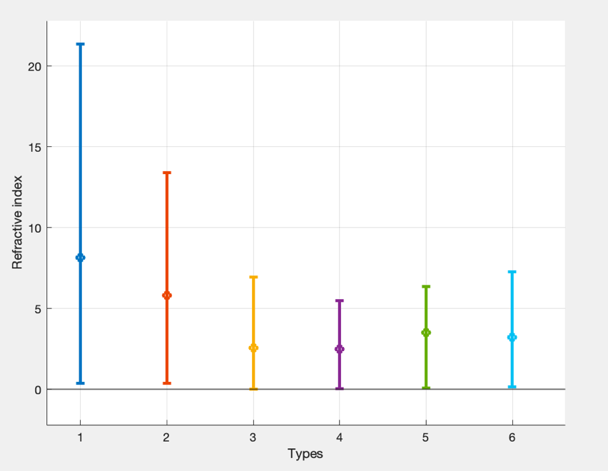
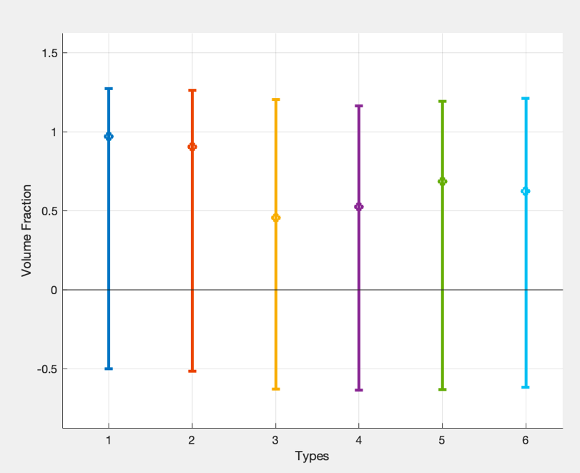
Type plot for refractive indices and volume fraction, due to uncertainties of $d_{film}±0,5μm$, $d_{ref}, d_{sam}±20μm$

Discussion

Future work

Conclusions

References
https://www.toptica.com/products/terahertz-systems/time-domain/teraflash-pro?gad_source=1&gad_campaignid=11174164687&gbraid=0AAAAACcXkr4qej04YU3L2IcDEkUEAKXEg&gclid=Cj0KCQiAxJXJBhD_ARIsAH_JGjhTIgyeGvxpCblPZhtStP0b_JkqpdiC-K26FiAEXBBShBT-Nh_CbYQaAqNuEALw_wcB#gallery-1
https://www.youtube.com/watch?v=X7vrvQcmy8c

Bibliografi

[1] | L. Madsen, »3.2 Refractive index by phase shift,« Terahertz Time Domain Spectroscopy for characterizing thin films, 3 June 2001.

